Natasha A. Kowo

nkowo@ecuad.ca + MDES location + https://natashaakowo.squarespace.com

Bio: 25-words, include whatever is relevant for you; your undergrad education would be important/helpful
- Typography allows me to say what I to say and show what I want to show. Typography is my language and is how I express. Criticism has had a significant role in my work as a student. Receiving feedback and changes allows me to improve my designs. To me, graphic design is about having an aesthetic that only you can understand, being creative, and bringing something to life. With my designs, I strive to

Keywords for your practice/research: (include 5)
- Typography
- Editorial
- Graphic design
- Women
- Aesthetic

Research questions/Key themes: does not have to be long, think 50 words.
- How can I change the exhibit insecurities that negatively affect black students in design?
- My key theme is to bring recognition towards my work as black female designer.
- The important of typography and colour is a key theme I want focus on during my study at Emily Carr.

Include up to 3 “actions” from the studio
- Rhythm
- Contrast
- Movement

Images: a grid of small-ish images so that people can get a sense of what you’re doing, or of previous work that may be related… Feel free to use a table format if you feel that will be an easier layout or a more intuitive read. All text should be condensed to a 1-page equivalent. Only expand your Design + Research Statement if the additional space is for images.

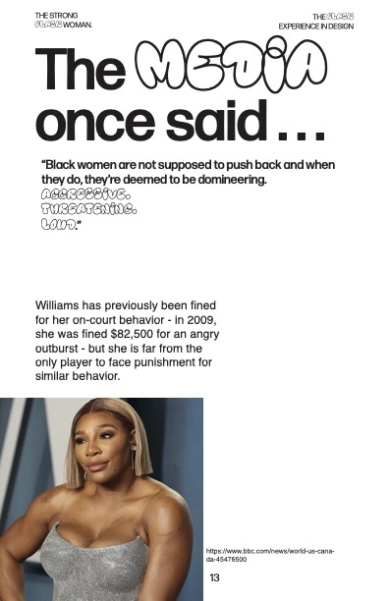  Serena Williams + prompt 3: THE STRONG BLACK WOMAN/28.10.2022 | 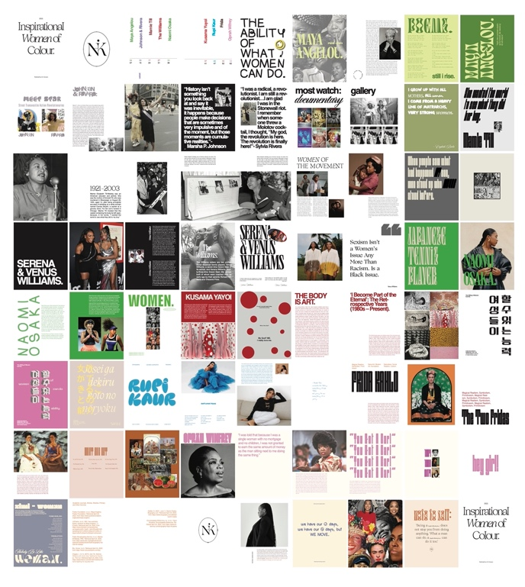  Thumbnails + Inspirational Women of Colour/2021-2022
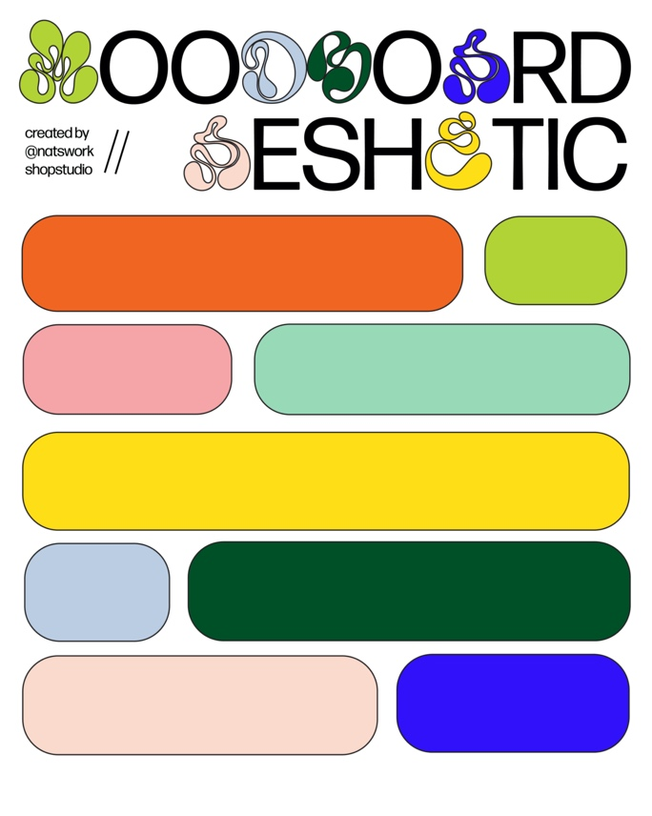  Moodboard Aeshetic + 13.10.2022 | 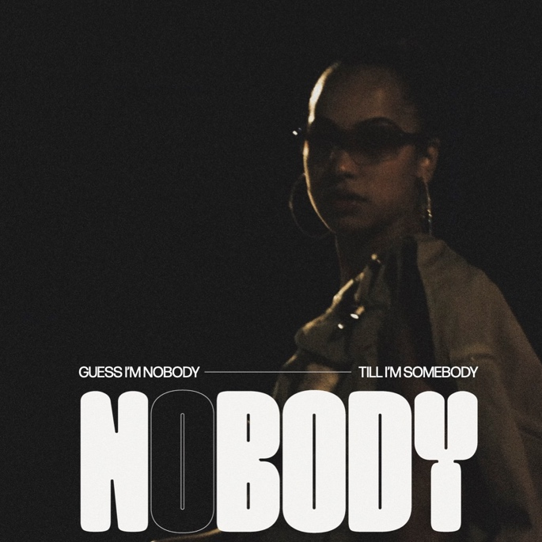  Toronto based Musician+ Nobody/Oct.2022

